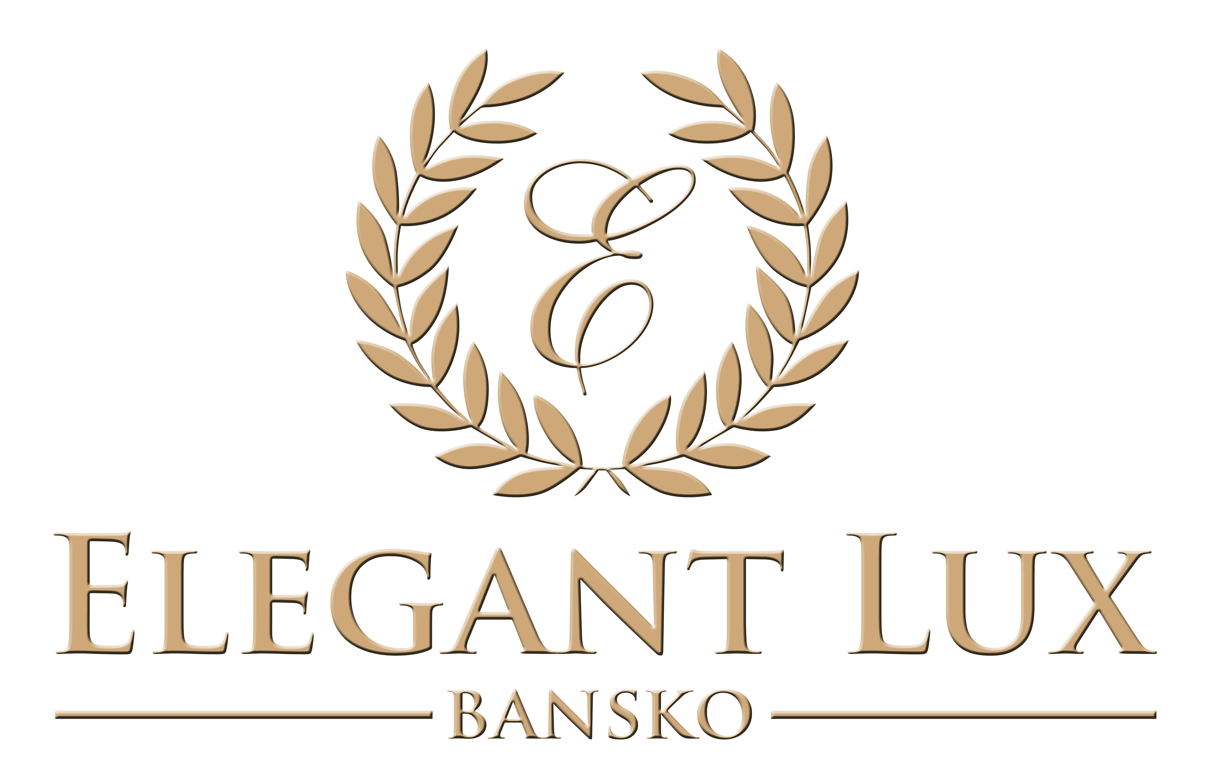

“Elegant Lux” is a superb holiday complex situated in the picturesque all - season resort of Bansko. The hotel’s outstanding location, conveniently close both to the main gondola lift which is only 3 minutes away, and to the old town, which is reachable in 7 minutes, makes it the perfect choice for spending unforgettable holidays for you and your family.
There are 47 apartments – studios, family apartments and one, two and three bedroom apartments accommodating up to 8 people. The Studios, One and Two bedroom Apartments have fully equipped kitchen, ideal for families and friends on holiday in Bulgaria. All of the apartments provide spectacular views of the 3 surrounding mountain ranges – Pirin, Rila and Rhodopi.
After a day of skiing, playing golf or walking in the mountain, there is nothing more rewarding to the body and soul than the precious time spend in Elegant Lux’s SPA Center including an indoor swimming pool, Jacuzzi, Turkish bath, steam bath, infrared sauna, Finnish sauna, fitness, steam cabin. Enjoy a relaxing beauty treatment in the Wellness center and take advantage of the wide range of massages and spa therapies. Furthermore, you can get a manicure, pedicure and a new hairstyle in order to look magnificent for the night.
The Lobby bar with the welcoming fireplace is the perfect place for meeting with your friends, relaxing or enjoying a drink in a good company. The restaurant offers a wide variety of specialties and during the night there is also live music.
The hotel has also children’s room, table tennis, billiards and a conference room.
Elegant Lux offers superb accommodation and services that will satisfy even the most refined guests, with a unique blend of luxury and tranquility in one of Europe’s fastest growing ski resorts.

Free transfer to the ski lift and back is provided during the ski season.

Hotel Facilities – Elegant Lux
- Restaurant
- Lobby Bar
- Conference hall
- 24 hour reception
- Garden
- Fishing pool
- Parking
- Free Wi-Fi Internet
- Non-smoking rooms
- Family Rooms
- Lift
- Express check-in/check-out
- Central heating
- Baggage storage room
- Ski room
- 24 hour room service
- Children’s Room
- Table tennis
- Billiards
- Spa Center
  - Indoor swimming pool
  - Jacuzzi
  - Finish Sauna
  - Shocking shower
  - Fitness
  - Steam bath
  - Salty room
  - Steam cabin
  - Massage
  - Spa therapies
  - Turkish Bath – Hammam

- Room Types: 9 Studios, 19 One-bedroom Apartments, 3 Two-bedroom Apartments with living room and kitchen, 7 Family Rooms. Some apartments have fireplace.

- Studio – 1 room, 1 bathroom – The studio is about 43 square meters. It is ideal for a couple, friends or a family from 2 to 4 people. It has a king-size bed and a sofa bed with a coffee table, dining table and a kitchen with a cooker, hot plate, fridge, microwave, kettle, toaster, plates, glasses, etc.

- One-Bedroom Apartment – about 65 square meters – 2 rooms, 1 bathroom – bedroom and a living room with a kitchen. It is ideal for a couple, family, or friends – from 2 to 4 people. It has a king-size bed or 2 single beds in the bedroom. In the living room there is a sofa bed with a coffee table, dining table and a fully equipped kitchen with a cooker, hot plate, fridge, microwave, kettle, toaster, plates, glasses, etc.

- Two-Bedroom Apartment – about 120 square meters – 3 rooms, 2 bathrooms or 1 bathroom and 1 toilet – 2 bedrooms and a living room with a kitchen. It is ideal for a big family, or a group of friends – from 4 to 6 people. It has a king-size bed in the one bedroom and 2 single beds or 1 king size bed in the second bedroom. In the living room there is a sofa bed with a coffee table, dining table and a fully equipped kitchen with a cooker, hot plate, fridge, microwave, kettle, toaster, plates, glasses, etc.

- Family Room – about 65 square meters – 2 rooms, 1 bathroom – 2 bedrooms. It is ideal for a family, or friends – 4 regular beds.

