Отели, из которых удобно добираться до Экспо на метро.

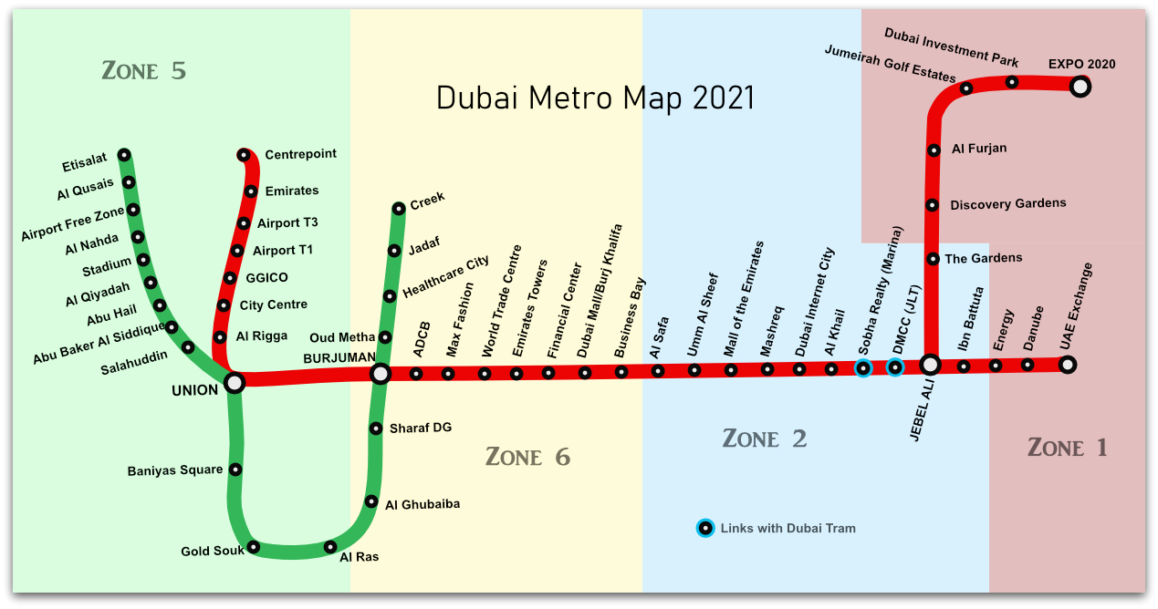

До выставочных павильонов удобно добираться по красной линии дубайского метро (ветка Route 2020).

Станция | Отели
Ibn Babuta | Avani Ibn Battuta Dubai Hotel  Oaks Ibn Battuta Gate Hotel Dubai  Premier Inn Dubai Ibn Battuta Mall
DMCC | Amwaj Rotana Jumeirah Beach  Millennium Place Marina  Stella Di Mare Dubai  Ramada Hotel & Suites By Wyndham Jbr (ex. Hawthorn Suites)  Sheraton Jumeirah Beach  Roda Amwaj Suites APARTMENT  Address Beach Resort  Sofitel Dubai Jumeirah Beach  Hilton Dubai The Walk  Address Dubai Marina  Marina Byblos Hotel  Jannah Place Dubai Marina APARTMENT
Sobha Realty | Marina View Hotel Apartments  Rixos Premium Dubai  Movenpick Hotel Jumeirah Beach  JA Oasis Beach Tower APARTMENT  The Ritz-Carlton, Dubai  Barcelo Residences Dubai Marina APARTMENT  Le Royal Meridien Beach Resort & Spa  Habtoor Grand Resort & Spa  Grosvenor House
Internet City | Two Seasons Hotel & Apartments  Grand Plaza Movenpick Media City  Mercure Dubai Barsha Heights Hotel Apartments  DusitD2 kenz hotel  Grand Millennium Dubai
Mashreq | Novotel Dubai Al Barsha  Cosmopolitan  Golden Tulip Al Barsha  MD Hotel  Donatello Hotel  Signature Al Barsha
Mall of the Emirates | Kempinski Hotel Mall of the Emirates  Flora Al Barsha
Dubai Mall - Burj Khalifa | Sofitel Dubai Downtown, Address Sky, Address Boulevard
Financial Centre | Carlton Downtown  Gevora Hotel  Rose Rayhaan by Rotana  Towers Rotana
Emirates Towers | Millennium Plaza Hotel

