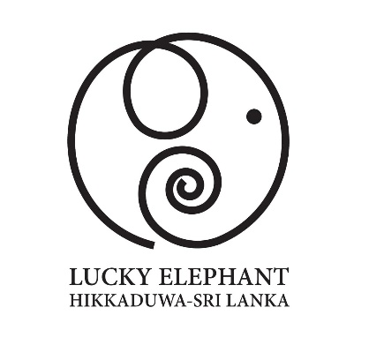

***Lucky Elephant Hotel (PVT) Ltd***

*No 878, Galle road, Thiranagama, Hikkaduwa, Sri Lanka 80240*

*Tel: +94 91 227 4880/ 4881/ 4882 | Website:* [*www.luckyelephanthotel.com*](http://www.luckyelephanthotel.com)

*Email:* [*info@luckyelephanthotel.com*](mailto:info@luckyelephanthotel.com)

***ABOUT LUCKY ELEPHANT HOTEL***

***Lucky Elephant Hotel*** *is located in one of the most popular tourist destinations in Sri Lanka, in the city of Hikkaduwa, which is the first and one of the most famous tourist destinations in the island. The hotel is situated in a quiet area directly on a beautiful long and calm sandy beach, right by the famous "Golden Sandy Beach". It is located 2 km’s from the tourist center of Hikkaduwa where there are shops, restaurants, supermarkets and banks and away from the noisy party area.*

*The nearest ATM is about 500 meters from the hotel. The distance from the airport in Colombo is 140 km’s, to the popular historical city of Galle fort it is 22 km’s. There is a beautiful beach for snorkeling lovers, where they can observe sea turtles and colorful sea fish. At this beach there is also a Coral reef with an exhibition of various corals of different shapes and colors.*

*The hotel has a large swimming pool with a separate children's section and throughout the day there is hotel restaurant that serves all types of international and local dishes.*

*In addition to offering many water sports on the beach (surfing, diving, etc.), our hotel offers a beach-volleyball court and a hotel gym. For lovers of relaxation we have a spa, offering many types of massage - from classical and sports to popular local Ayurveda massages.*

*Free Wi-Fi is also available in the hotel. You will have your own sun loungers with parasols by the pool or on the beach.*

*The hotel offers a total of 24 rooms in 4 categories - Standard, Deluxe, Superior and Luxury Suite.*

*All rooms have a private balcony, TV, minibar, safe lockers, Air-conditioning, ceiling fans, and a bathroom with a shower, toilet and hairdryer etc. An elevator is also available in the hotel building.*

*In the hotel restaurant guests can order European, Asian and typical local dishes. We also offer many types of alcoholic and non-alcoholic drinks and a variety of cocktails at the hotel bar.*

***“Feel the Sun, Sand and Sea“***

***Room Categories & information***

1. **Standard Double (Green view Double)**

*Total rooms: 02*

*View: Courtyard view*

*Balconies: Yes (Private balconies)*

*Bed type: King Size bed*

***GUESTROOM FEATURES***

*• Coffee/tea making facilities. • Personal in-room safe. • Room service. •Air-conditioning • Satellite TV. • 32” colored LED TV • Hair dryer. • Mini-bar. • Iron & ironing board • Hot/Cold water • Iron & ironing board.*

1. **Deluxe Double (Sunset ocean view Double)**

*Total rooms: 04 DBL / 02 Twin (including 02 Interconnecting)*

*View: Side sea view*

*Balconies: Yes (private balconies)*

*Bed type: King Size bed or Twin beds*

*GUESTROOM FEATURES*

*• Coffee/tea making facilities. • Personal in-room safe. • Room service. •Air-conditioning • Satellite TV. • 32” colored LED TV • Hair dryer. • Mini-bar. • Iron & ironing board • Hot/Cold water • Iron & ironing board.*

1. **Superior Double (Ocean view Double)**

*Total rooms: 02*

*View: Direct sea view*

*Balconies: Yes (private balconies)*

*Bed type: King Size bed*

*GUESTROOM FEATURES*

*• Coffee/tea making facilities. • Personal in-room safe. • Room service. •Air-conditioning • Satellite TV. • 32” colored LED TV • Hair dryer. • Mini-bar. • Iron & ironing board • Hot/Cold water • Iron & ironing board. • Bath robes*

1. **Superior Triple (Ocean view Triple)**

*Total rooms: 02*

*View: Direct sea view*

*Balconies: Yes (private balconies)*

*Bed type: 1 King Size bed & 1 Single bed*

*GUESTROOM FEATURES*

*• Coffee/tea making facilities. • Personal in-room safe. • Room service. •Air-conditioning • Satellite TV. • 32” colored LED TV • Hair dryer. • Mini-bar. • Iron & ironing board • Hot/Cold water • Iron & ironing board. • Bath robes.*

1. **Luxury Suite (Panoramic Suite)**

*Total rooms: 02*

*View: Direct Sea view (Panoramic view)*

*Balconies: Yes (private balconies)*

*Bed type: King Size bed*

*GUESTROOM FEATURES*

*•Bath tub (Hot/cold) • Coffee/tea making facilities. • Personal in-room safe. • Room service. •Air-conditioning • Satellite TV. • 40” colored LED TV • Hair dryer. • Mini-bar. • Iron & ironing board • Hot/Cold water • Iron & ironing board. • Bath robes. • Sofa*

**6. Penthouse Apartment**

*GUESTROOM FEATURES*

This spacious apartment consists of 1 living room, 2 separate bedrooms and 1 bathroom with a walk-in shower and free toiletries. In the fully equipped kitchen, guests will find a stovetop, a refrigerator, kitchenware and an oven. The air-conditioned apartment provides a flat-screen TV with streaming services, a washing machine, a private entrance, soundproof walls as well as sea views. The unit offers two beds.

***Special arrangements:***

* *Infant cribs for infants aged 0-2 years available on request on complimentary basis.*
* *Rollaway or Extra Beds are available on additional charge on a per night basis.*

***Fitness & Spa***

*Gym: Hotel gym is open every day from 6 AM to 10 PM. It is free of charge for all hotel guests.*

*Massages are being charged extra, depending on the massage type and are available from Monday to Saturday 8 AM - 8 PM.*

***Operational hours***

* *Reception: 24 Hours*
* *Room service: 9Am to 8Pm*
* *Restaurant: 7.30Am to 10Pm*
* *Kitchen: 7.30Am to 10 Pm*
* *Bar: 9Am to 11Pm*

***Restaurant & Bar***

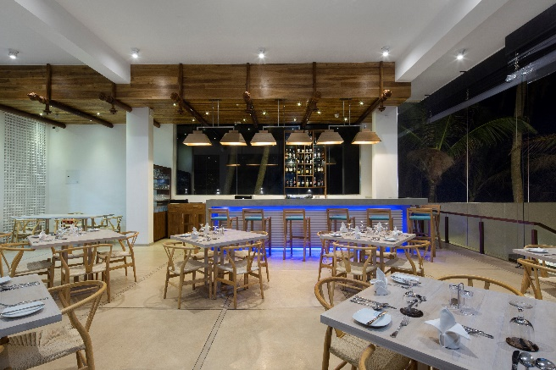

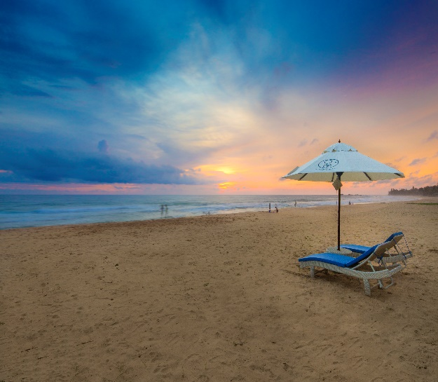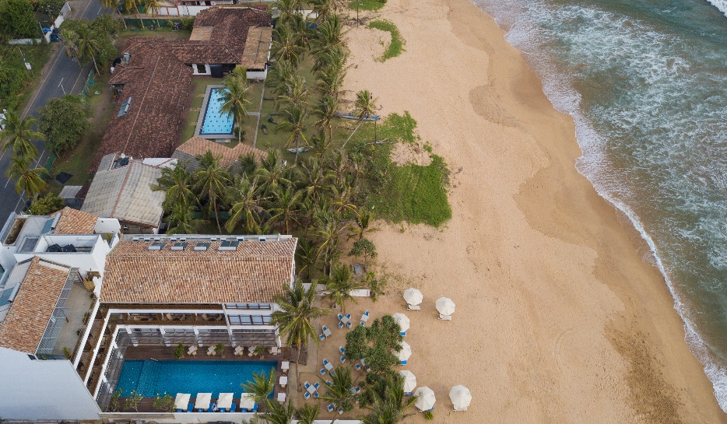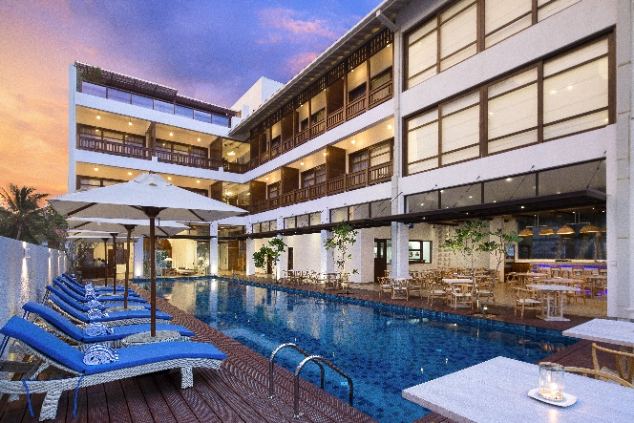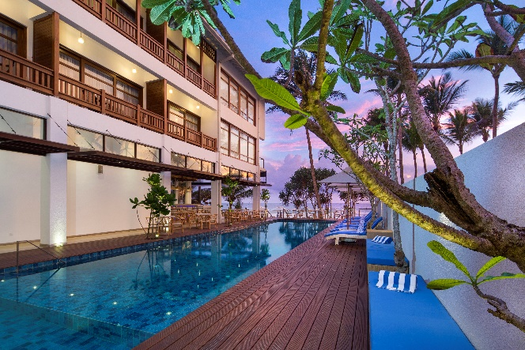

***Swimming Pool and the pool deck***

***Beach area***