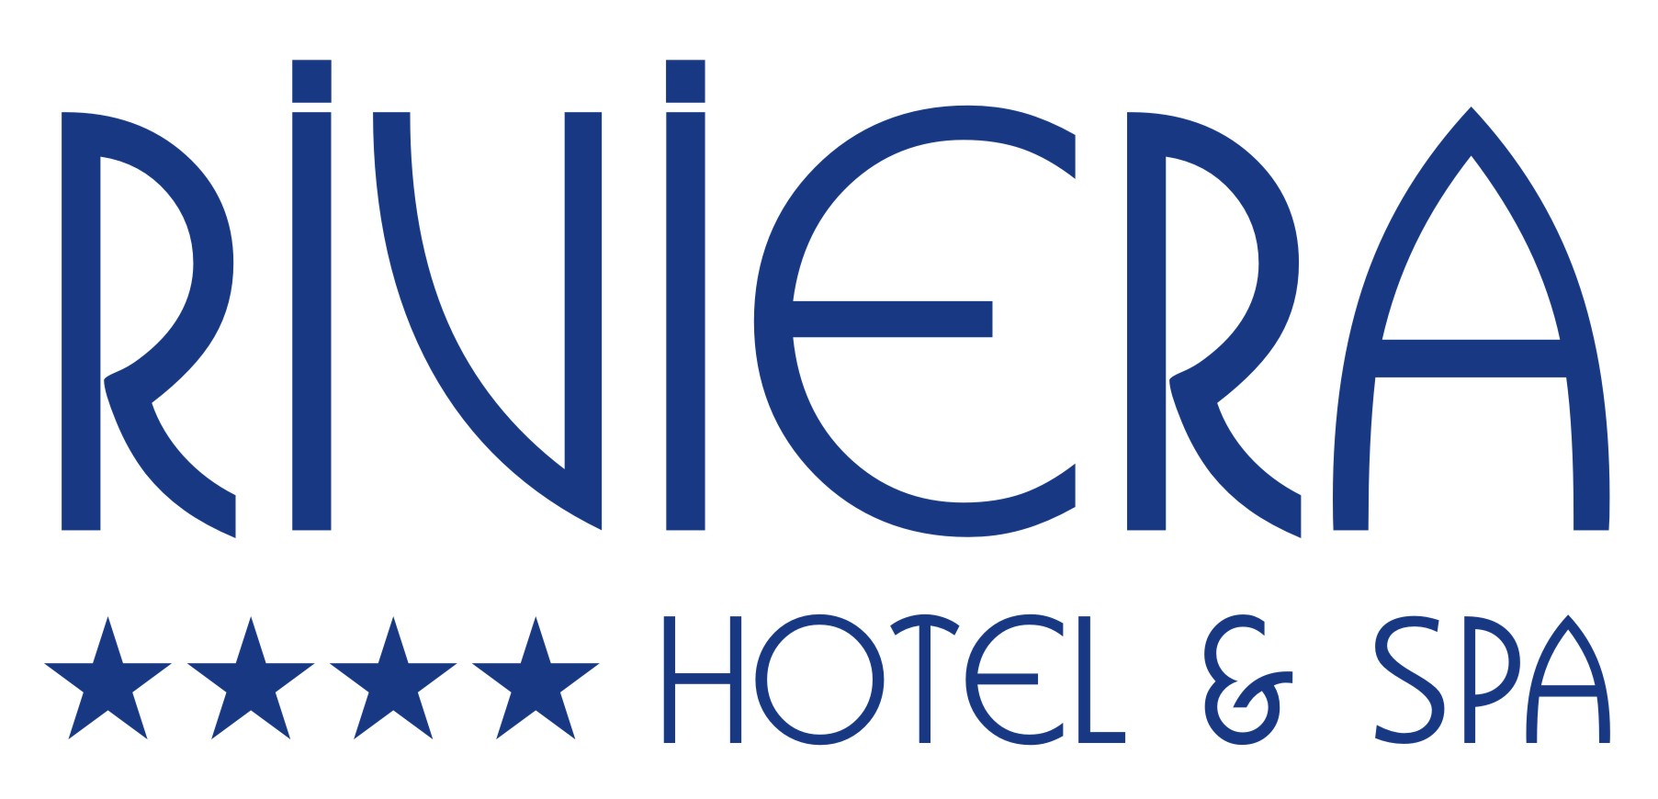

LOCATION :
The hotel has been seperated with a street from the famous Cleopatra beach ( 50 m.)
You may reach to Alanya city center with various entertainment possibilities,
in a few walking-minutes. Bus services available. Transfertime from Airport Antalya ca.115 min. and Alanya-Gazipaşa Airport ca.35 min.

BUILDING :
This well-known hotel with it’s continued guests has 193 rooms in 5 floors and 3 buildings, offers a comfortable Lobby with Reception, Lift, Lobby Bar, TV-Corner, Restaurant with non-smoking area and Terrace, Pool Bar. There are also 2 Swimming Pools with seperated Child Pool and Indoor Pool in C Block.

ROOMS :
With modern furnitured rooms with Laminate flooring, Safe Box ( FREE), Shower / WC, Hair-Dryer, Satelite-TV, Minibar, Music Channel over TV, Individual adjustable Wireless , Airconditioner, Direct-dial telephone and balcony. All rooms are Non-smoking. Room service and handicap friendly room.

SPA & CENTER:
Indoor pool , Türkish bath, Sauna, Fitness room and massage rooms.
You may use Türkish bath and Sauna between 15.30-17.30 o’clock with free of charge.
Massages are with extra charge.

ACTIVITIES :
Free of charge: 2 x Live music in the week. WI-FI at the lobby and in rooms. Fitness Room, Umbrellas,Mattresses and Sun beds will be offered free of charge at the pool .

With Charge : Beach volleyball , 4 Public Tenis Courts across the street, Room Service, Hairdresser, Laundry, various Water sports which will be offered from local firms during the season. Charge at the our beach for umbrellas and sunbeds.

Occasionally entertainment programs will be organised.

ACCOMODATION :
All-inclusive.
Breakfast, Lunch and Dinner in buffet form. Late breakfast, Afternoon Cake and ice cream. Local Alcohol and Non Alcohol Drinks are from 10 : 00 untill 23 : 00 o’clock
at the respectively opened Bars included.

BEACH :
Spacious, steeply sloping and rough sand beach. Parasols and Sunbeds are with additional charges. Towels are not available.

