
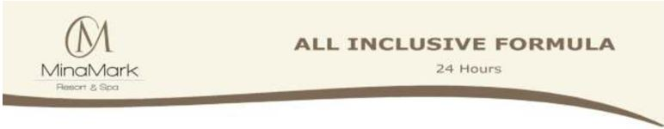
.
Password: mm2030
User Name: Lobby
MinaMark Beach Resort & Spa Team are delighted to welcome you and will save no efforts to make your holiday a memorable one

Food & Beverages Services Timing

Main restaurant | Water Blue | Sunshine
Breakfast | 07:00 – 10:00 Buffet | 07:30 – 10:00 Buffet
Lunch | 13:00 – 15:00 Buffet | 12:30 – 14:30 Buffet
Dinner | 18:30 – 21:00 Buffet | 18:30 - 20:30 Buffet
Late Dinner | 22:30 – 02:00 Cold cut | only late arrivals & outside trips
- Served Buffet is an excellent option for family dining due to Covid-19 protocol. Each person can
choose whatever he or she wants, and if they don't get enough during the first round, a second trip to the serving dishes is typically allowed.
- Most buffet style restaurants have a policy of not allowing taking food outside the restaurant.
You may eat all you want, as long as you do it there, breakfast & lunch boxes requests are welcomed in case of early trips (one day ahead of requested time).
Snacks Service Policy and Timing:
- The Beach Bar Snacks timing from 10:30 till 12:00 hrs.
- The Beach Bar afternoon Snacks timing from 16:00 till 17:00 hrs.
- The Pool Bar afternoon Snacks timing from 16:00 till 17:00 hrs.
- The Italian Restaurant Snacks timing (Hard All Inclusive only) from 16:00 till 17:00 hrs.
- The Beach Bar Ice cream timing from 13:00 till 15:00 hrs.
- A la carte restaurants free of charge only for reservations of 5 nights Hard All Inclusive:
- Italian restaurant “Piccola Italia” and Chinese restaurant “Yum Yum”
- Reservation of tables please contact with Guest Relation daily from 12:00 to 13:00 hrs.
Beverage Service Policy and Timing:
- Main Buffet Restaurant serves soft drinks during Lunch & Dinner time.
- Pool Bar serves drinks 24/7 by glass policy basis.
- Beach Bar serves drinks from 10:00 till 17:00 hrs.
- Lobby Bar “Ora” serves hot and soft drinks with extra charge.
Hard Drinks served by glass for Hard All-inclusive only:
- Local Beer, local Wine, local Alcoholic (Gin, Vodka, Rum, Brandy, Ouzo, Whisky).
- Soft drinks (Cola, Fanta, Sprite, and Soda), mineral water, juices
- Alcoholic Cocktails, Non Alcoholic Cocktails.
- Hot drinks (Tea, Coffee, Anise, Mint, Hot chocolate).
Please note:
- The aqua park for adults and children is open from 10:00 a.m. to 1:00 p.m. and from 3:00 p.m. to 5:00 p.m.
- The all-inclusive wristband must be intact and presented to hotel staff upon request. Loss of the wristband will result in a $10 charge.
- If you don't want to be disturbed at the pool or beach, please attach the red flag on your umbrella. You will get this from the towel center.
- Sun loungers that are without guests for more than one hour will be offered to other guests. The
towels will be removed by the lifeguards.
- It is forbidden to take outside food and drinks with you
- Lobby bar, mini bar, laundry, internet WiFi (except lobby area), billiards, spa cost extra
- Check-in: 2:00 p.m. Check-out: 12:00 p.m.

We wish you a pleasant stay at the MinaMark Resort & Spa- Hurghada

