TheLifeCo Sharm el Sheikh
Fact Sheet

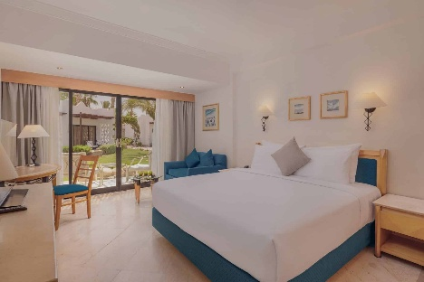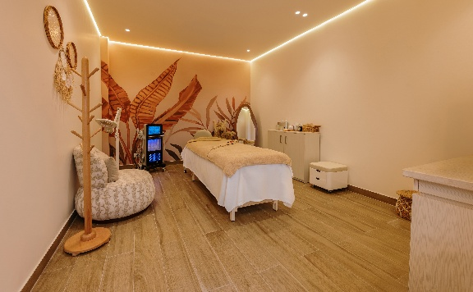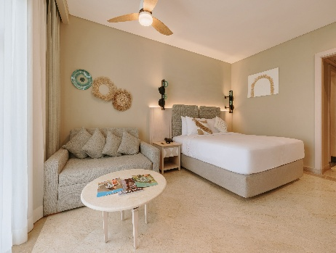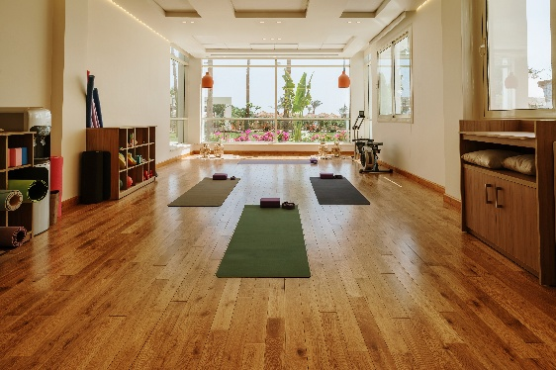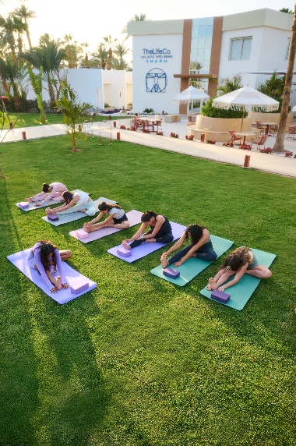

FACILITY INFORMATION

- Rooms:19 Deluxe Rooms , 31 Standart Rooms
- Juice Bar & Restaurant
- Clinic
- Yoga Sala
- Spa (Massage and Beauty areas, Infrared Sauna, Turkish Hammam, Steam Room)
- Beach
- Gym

PROGRAMS

- Weight Loss & Management
- Cleansing & Detox
- Mental Wellness & Stress Recovery
- Chronic Disease Management
- Longevity & Biohacking
- Guilt-Free Programs
- Diabetes & Metabolic Reset
SERVICES PROVIDED

- Detox & Nutrition
- Medical Consultation and Wellness Assessments from Wellness Experts
- Daily Clinic Services, Body Composition Analysis
- Infrared Sauna, Steam Room, Turkish Bath (Self Using), Turbosonic Vibration Therapy
- Self-Service Biohacking Devices,
- Daily activities - Group Exercise, Yoga & Pilates
- Educational Sessions

LOGISTICAL INFORMATION
- Distance from airport is 11 km and takes around 15 minutes by Taxi

